**SOMECOLLEGE Database Queries**

1. Return all rows if the ID is 2348, 1255, 8455, 4890

SELECT *

FROM STUDENTS

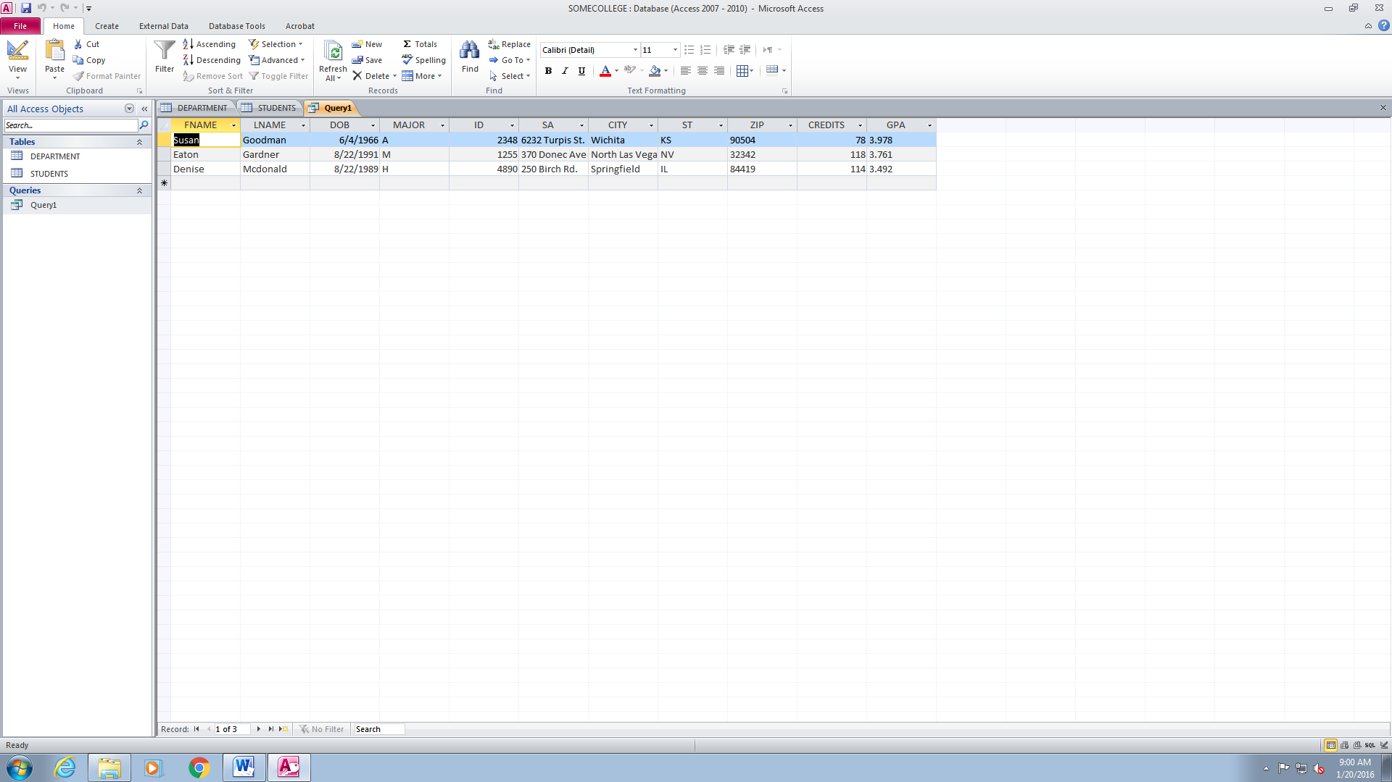WHERE ID=2348 or ID=1255 or ID=8455 or ID=4890;

1. Return all rows if the city name contains the letter ‘o’

SELECT *

FROM STUDENTS

WHERE CITY LIKE "*o*";

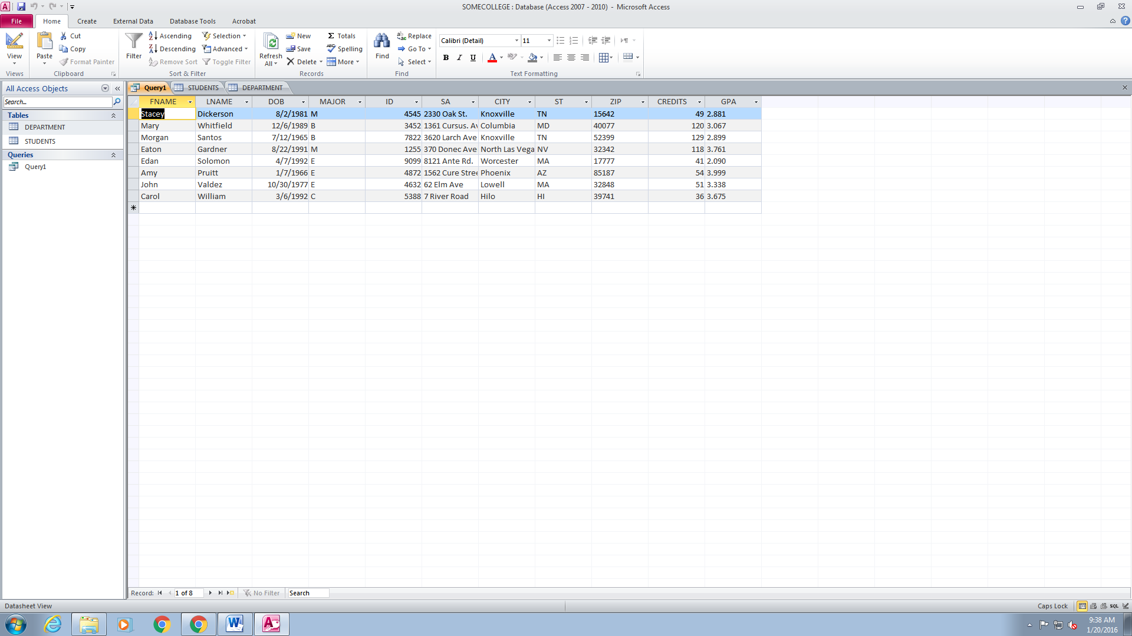

1. Return full name and DOB if the last name does not contain the letter ‘a’ or ‘e’

SELECT FNAME, LNAME, DOB

FROM STUDENTS

WHERE LNAME NOT LIKE 'a' or NOT 'e';

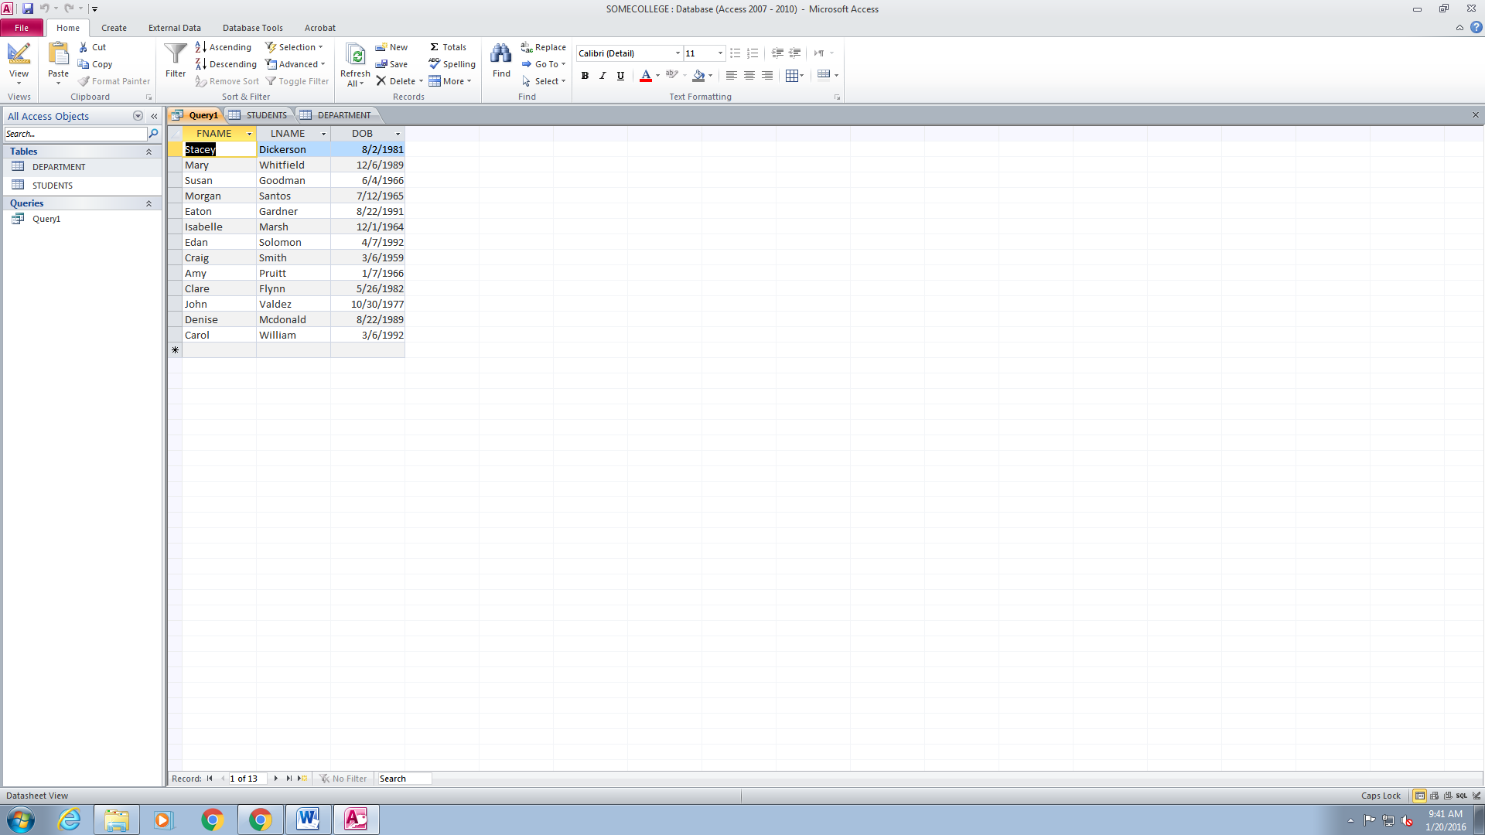

1. Return full name and GPA if the student has a GPA of 2.000 to 3.000

SELECT FNAME, LNAME, GPA

FROM STUDENTS

WHERE GPA BETWEEN "2.000" and "3.000";

1. Return full name, GPA, STATE of all students who live in Hawaii or have a GPA greater than 3.500

SELECT FNAME, LNAME, GPA, ST

FROM STUDENTS

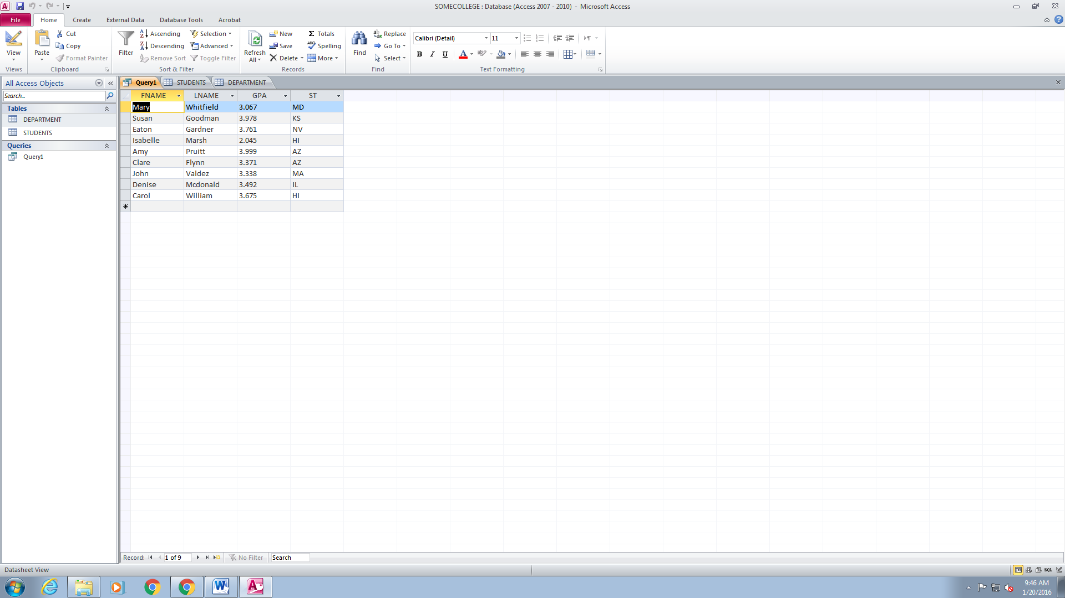WHERE ST = "HI" or GPA > "3.000";

1. Return full name, DOB, MAJOR, and ID